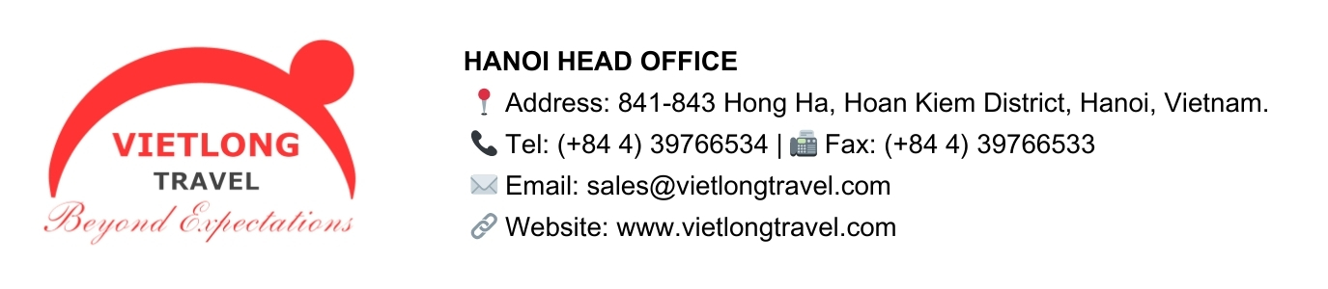

10-Day Thailand Sightseeing Tour with Phuket Beach
Destination: Bangkok – Chiang Mai – Phuket
Brief itinerary:
Day 1 – Arrive Bangkok; hotel check-in. (— | Bangkok)
Day 2 – Bangkok full-day tour: (B | Bangkok)
Day 3 – Night train Bangkok → Chiang Mai (B | Chiang Mai)
Day 4 – Chiang Mai Tour
Day 5 – Chiang Mai (B | Chiang Mai)
Day 6 – Fly Chiang Mai → Phuket; beach check-in; sunset. (B | Phuket)
Day 7 – Phuket:. (B | Phuket)
Day 8 – Free beach day (B | Phuket)
Day 9 – Phuket: (B | Phuket)
Day 10 – Phuket → onward flight. (B | —)

Day 1 – Arrive Bangkok; hotel check-in.
Touch down in the City of Angels and meet your guide for a smooth transfer to the hotel. The rest of the day is yours to shake off jet lag and wander at your own pace. If you’re up for it, take an evening stroll along the riverside, sample your first bowl of boat noodles, and feel the energy of Bangkok’s neon nights set the tone for the journey ahead.
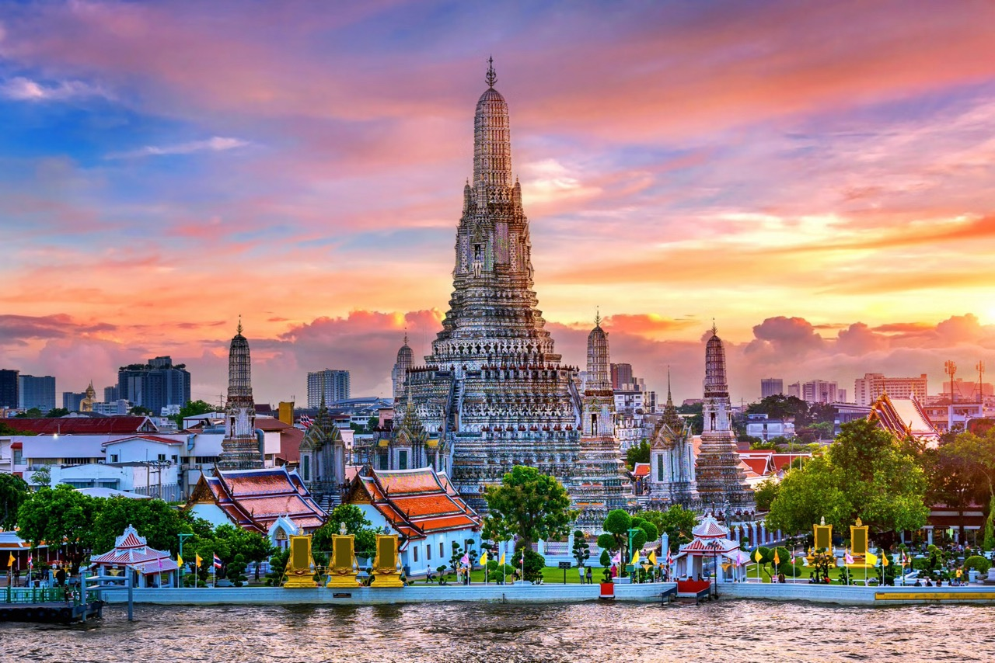
Overnight: Bangkok | Meals: —
Day 2 – Bangkok full-day tour
Morning, breakfast at hotel then meet our guide and driver for Experience Bangkok’s highlights and history on a full-day tour through the heart of the city, first a visit to the Royal Grand Palace, the nation’s landmark and most praised royal monument in Thailand, with the enclosed and dazzling Wat Phra Keo with its revered Emerald Buddha, the Golden Chedi, the Pantheon of the Chakri Kings and the Eight Coloured Towers, is a must.
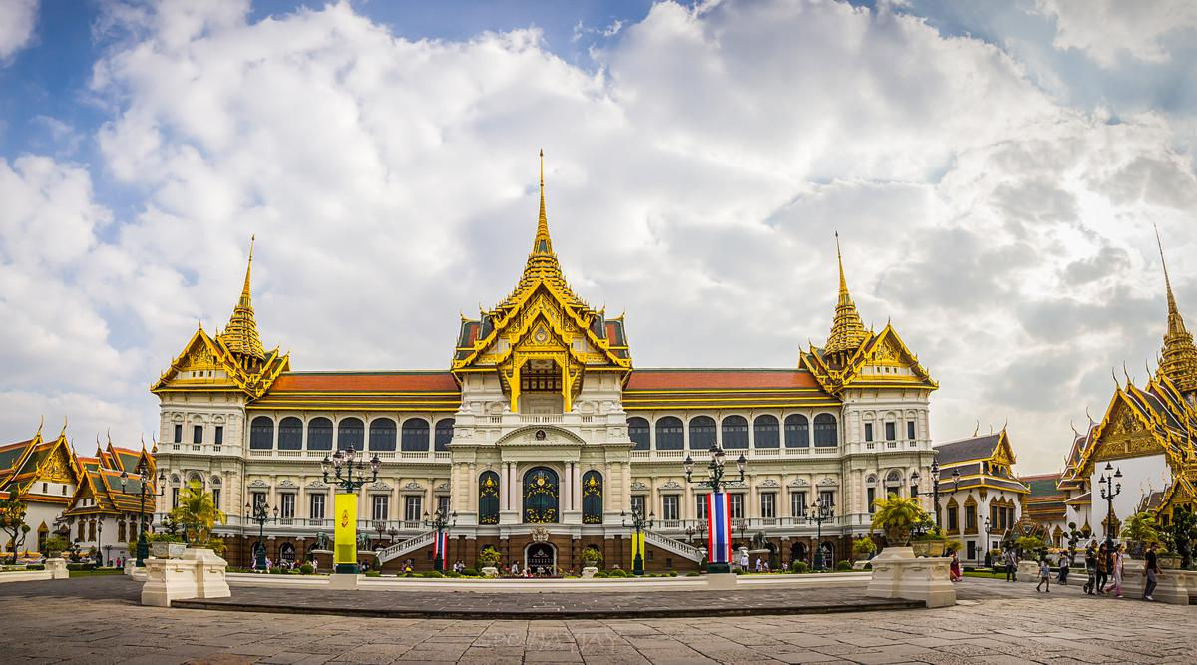
In Thailand by many, it is considered to be a living example of classical Siamese Court, being the former residence of the kings of Thailand. Wat Pho is also regarded as the first centre of public education and is sometimes called ‘Thailand’s first university’. Mural paintings, inscriptions, and statues found in the temple-educated people on varied subjects such as literature, warfare, archaeology, astronomy, geology, meditation and to be considered, home of the Thai traditional massage. Here, you will enjoy a 30-minutes’ Thai massage as an excellent break after a morning sightseeing (not included Massage fee).
Lunch at local restaurant and after lunch time you enjoy an afternoon trip along the bustling Chao Phya River and the quiet Klongs (canals) in a long tail boat or big boat enjoy scenes of life by water. We bring you to a more traditional way of living, more serene and traditional, away from all the high-rise and modern buildings of Bangkok City Centre, as we gently pass Thonburi residential areas. A stop will be made at the “Temple of Dawn” (officially named Wat Arun) – it is one of the most spectacular and recognizable Thai landmarks. Idyllically situated amongst picturesque river scenes, capturing the stunning contrast with the surrounding modern cityscape. End of tour at hotel.
Noted: Photography is permitted in the Royal Palace Grounds and in the compounds of the Emerald Buddha Temple, but not inside the buildings.
Dress code: Please dress respectfully by not wearing sleeveless, shorts or sandals, when visiting the Grand Palace and temple complex.
Tours on Sundays: The inner courts of Grand Palace are frequently closed on Sundays; we recommend not to book this excursion on Sundays to avoid disappointment.
Overnight: Bangkok | Meals: B
Day 3 – Full day Damnoen Saduak Floating market & Jim Thompson House - Night train Bangkok → Chiang Mai.
Visit Damnoen Saduak floating market, Phra Pathom Chedi and the beautiful countryside resort with Patom Organic Farm Tour
This most, interesting full day tour takes you to the rural yet world-famous floating market of Damnern Saduak, situated around 100 kilometres west of Bangkok. The tour includes a visit to Nakorn Pathom; site of the highest Chedi in Thailand called "Phra Pathom Chedi, which is the largest pagoda in Southeast Asia. An excellent international buffet lunch will be served at the picturesque Rose Garden Aprime Country Resort.
Visit the house of the late Jim Thompson, the American who revived the Thai Silk industry after World War II. This house – a perfect example for authentic Thai residential architecture and Southeast Asian art - consists of a complex of six traditional Thai-style houses, teak structures that were purchased from several owners and brought to the present location from various parts of Thailand. Construction of the Thai house was completed in 1959. A magnificent half-day, dedicated to one of the most remarkable achievements ever being made by a foreigner in Thailand, yet as mysterious his disappearance has been.

A leisurely morning invites you to discover local markets or choose an optional canal (klong) cruise through Bangkok’s quieter neighborhoods. In the late afternoon, board the overnight sleeper train to Chiang Mai. Settle into your cozy berth and watch the urban sprawl give way to rice fields and mountains. The rhythmic sway of the train becomes part of the adventure
Tour type: Private
Duration: 8 hours (08.00 - 17.00h)
Meals: Lunch
Overnight: On night train / Arrive Chiang Mai next morning | Meals: B
Special Express No. 9 — 18:40 → 07:15 (+1).
Day 4 – Full day Doi Inthanon National Park – The Highest Peak of Thailand
Pick up from the hotel lobby and depart to Doi Inthanon National Park, which is Thailand's highest mountain (2,565 meters above sea level) offers beautiful scenery, evergreen mountain forests, dwarf rhododendron groves, rare bird life, and impressive waterfalls. Visit to the Summit and short trek along Angka Nature Trail; explore and feel the beauty and the unforgettable nature around.
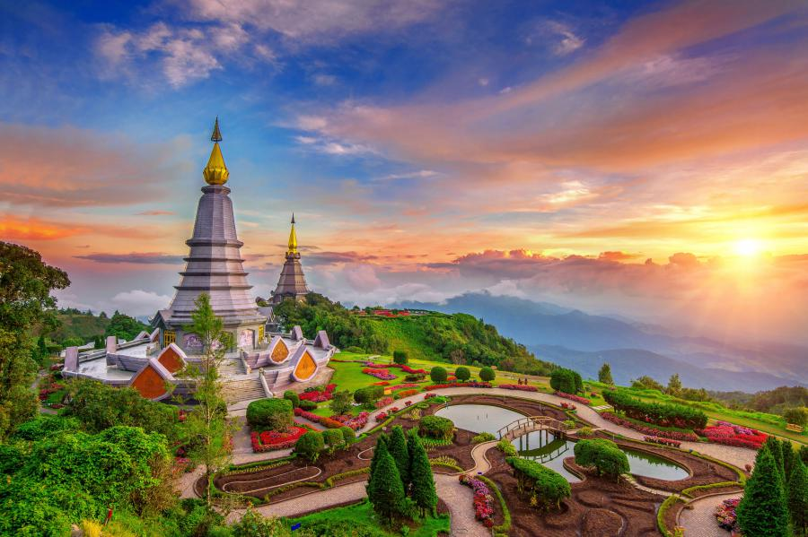
Continue to the great Twin Royal Pagodas, which were built for His Majesty the King and Her Royal Highness the Queen of Thailand. This place provides a marvelous view of its surroundings.
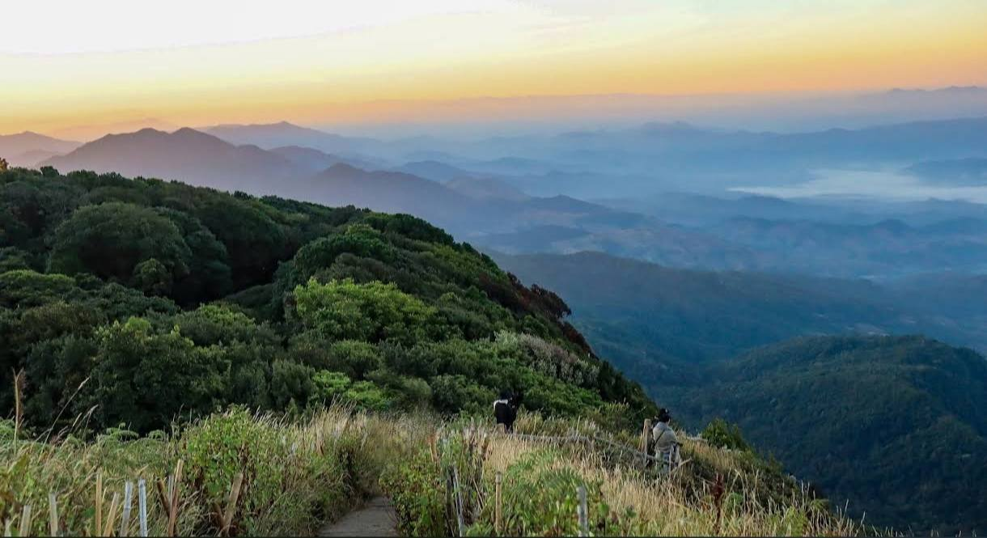
Lunch served at the local restaurant.
Depart to Doi Inthanon Royal Project, one of the many royal-sponsored projects to familiarize hill tribe people with new agricultural techniques. View the flower nurseries and cultivation areas. Then visit to Vachiratharn Waterfall, a large waterfall which plummets over the edge of a high cliff around 100 meters into a deep pool below. It is also one of the highest waterfalls in Northern Thailand, great to take pictures. Then transfer back to the hotel.
Overnight: Chiang Mai | Meals: B
Day 5 – Chiang Mai Free and Easy

Optional Tour: Full day Elephant Sanctuary & Bamboo Rafting
Tour type: Private
Duration: 7 hours (08.00 - 15.00h)
Meals: Lunch

Pick up from the hotel lobby and depart to Mae Taman Elephant Camp; (1½ hour drive) explore the spectacular mountainous scenery along the way. Watch Demonstrations of how trained elephants are used as working animals in teak forests. The show includes elephant painting, dragging and pushing logs, and responding to commands. Elephant Ride through the beautiful mountain scenery and Bamboo River Rafting cruise along the rural Mae Taeng River, softly moving along the river while relaxing as the raft’s men pole you down through farm houses and stunning greenery. Lunch served at the local restaurant. Continue to visit Orchid Nursery to see a large collection of different types of colorful exotic year-round-bloom
orchids. 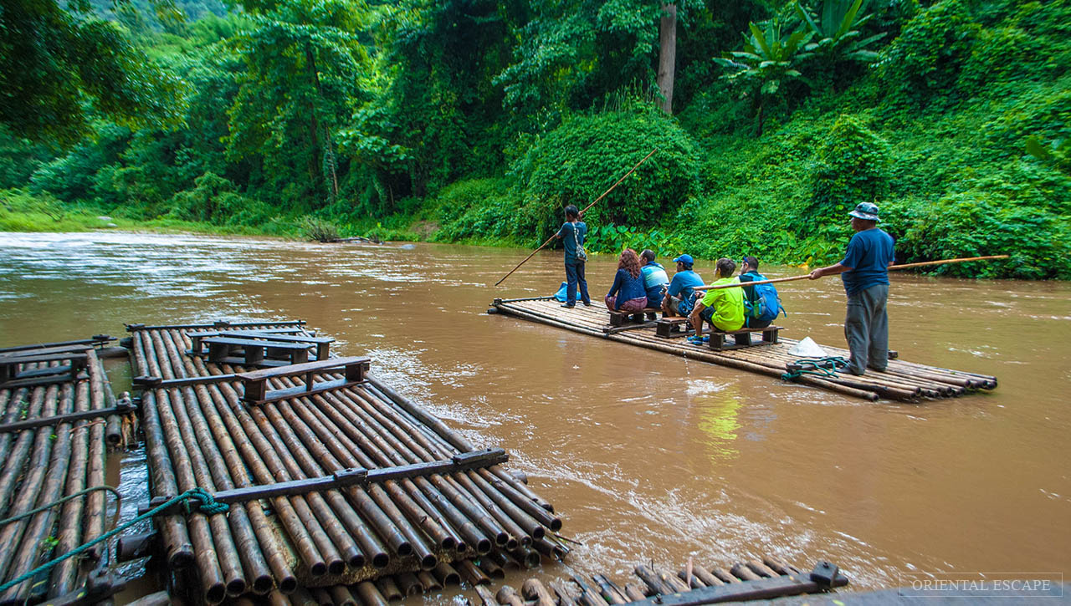Then transfer back to the hotel.
Price in USD per person

Included: Air-con Vehicle with English speaking guide, Lunch + Elephant show + Elephant riding and Bamboo Rafting & mineral water.
Remark:
- All rate provided for hotels located in City center, any supplement or conditions apply for hotels and resorts outsides the city center.
- Van provided in the quotation, if any bus requirement, the price will be updated case by case.
- If take out the lunch, deduction applied: - $10/pax
Overnight: Chiang Mai | Meals: B
Day 6 – Fly Chiang Mai → Phuket; beach check-in; sunset.
After breakfast, transfer to the airport for your flight south to Phuket.
Chiang Mai(CNX) - Phuket(HKT)
VZ4142 10:45 - 13:05
PG2482 14:35 - 16:40
Warm sea breezes greet you on arrival. Check in at your beach hotel and exhale—soft sands, swaying palms, and the Andaman’s blue horizons are your new backdrop. As daylight fades, take a barefoot walk along the shore and toast the sunset with a fresh coconut or your favorite drink.
Overnight: Phuket | Meals: B
Day 7 – Phuket Half-day City Tour
Meet your English speaking Guide at hotel lobby and spend short half day trip to see some of the more interesting places that showcases the island’s culture, viewpoints and sacred sites. You will visit Phuket Old Town – an area of historical interest in the city of Phuket, many old buildings have been converted into shops, hotels, restaurants, and museums. Continue to visit the Big Buddha statue – width 25,45m and height 45m, Reinforced concrete structure adorned with white jade marble, Suriyakanta, from Myanmar (Burma). The weight of the white jade marble is approximately 135 tons per 2,500 sq.m and was established on the top of Mount Nagakerd, Subdistrict Karon, Phuket Province.
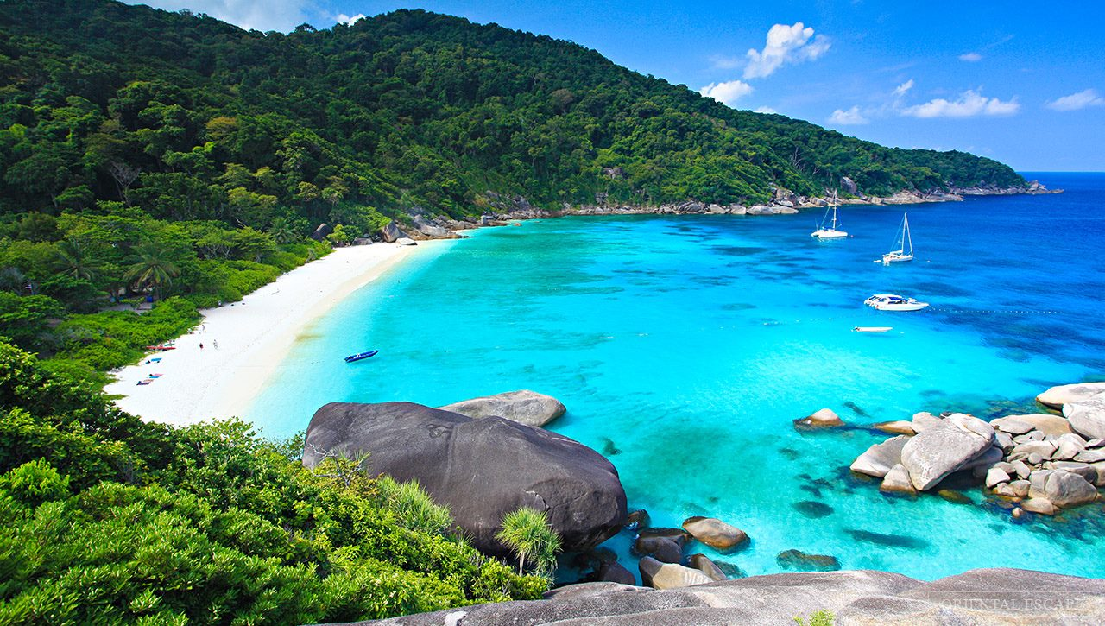
Duration: 4 hours (08.30 - 12.30h. or 13.00 - 17.00h)
Meals: None
Picked up/dropped off: Phuket
Tour end at your hotel.
Noted:
The price mentioned for hotels located in city center, if any hotels confirmed at picked up place at from Ao Yon, Cape Panwa, Ko Sire, Leam Hin, Ao Por, Naiyang, Naithorn, Layan, Mai Khao, Kamala, Surin, Bang Tao, and the Airport area, the price will be applied surcharged (to be advised)
Overnight: Phuket | Meals: B
Day 8 – Phuket Free and Easy for beach day or Optional Phi Phi Island speedboat.
A full day at leisure to do as much—or as little—as you like. Unwind poolside, try stand-up paddleboarding, or visit a nearby spa. If you prefer something livelier, take an optional speedboat to the Phi Phi archipelago for snorkeling in clear waters and basking on postcard-perfect beaches.

Optional: Full day Phi Phi island by Speed Boat
Tour type: Private driver and guide/sharing speed boat.
Duration: 8 hours (07.00 - 17.00h)
Meals: Thai Buffet Lunch
Picked up/dropped off: Phuket
Today you will enjoy a private trip to the Phi Phi Islands with a speedboat charter service, tailor your own timetable for each island for a unique experience.
Time: 70:00 pick up at your hotel then transfer to the pier.
Time: 09:00 start the exploration at Maya Bay, the first recommended destination where the movie “The Beach” was filmed. Capture the island scenery. From here, you can walk through the island to see Loh Sama Bay, a beautiful setting including a small green island planted in the Andaman Sea.
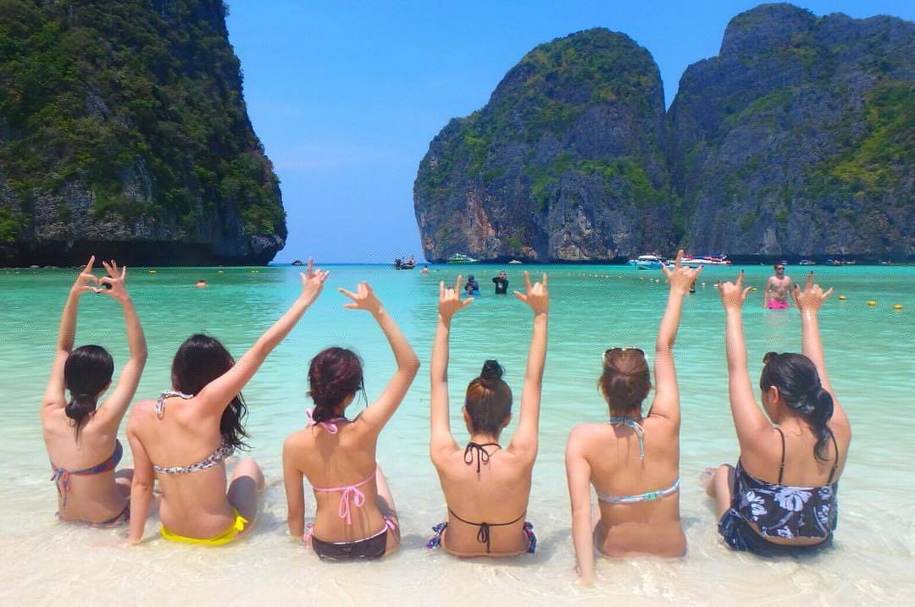
Time: 10:00 continue your journey for snorkeling at Loh Samah Bay and emerge yourself in the underwater world known for its tropical fish shining their vibrant yellow and blue coloring. Head toward the stunning view of Pileh Lagoon and make a short stop at Viking Cave to see where the Phi Phi birds nests are located. As we cruise onward, get ready to be dazzled by Monkey Beach. This 150-meter gem, nestled on the southwestern shore of Tonsai Bay, boasts powdery white sand lapped by emerald waters. Lush vegetation climbs the cliffs behind the beach, creating a haven for a colony of monkeys. Keep your eyes peeled – at low tide, you might spot them playfully foraging for breakfast right on the shore. While we won't be stopping at the beach itself, this glimpse of paradise is sure to be a highlight. Lunch at restaurant.
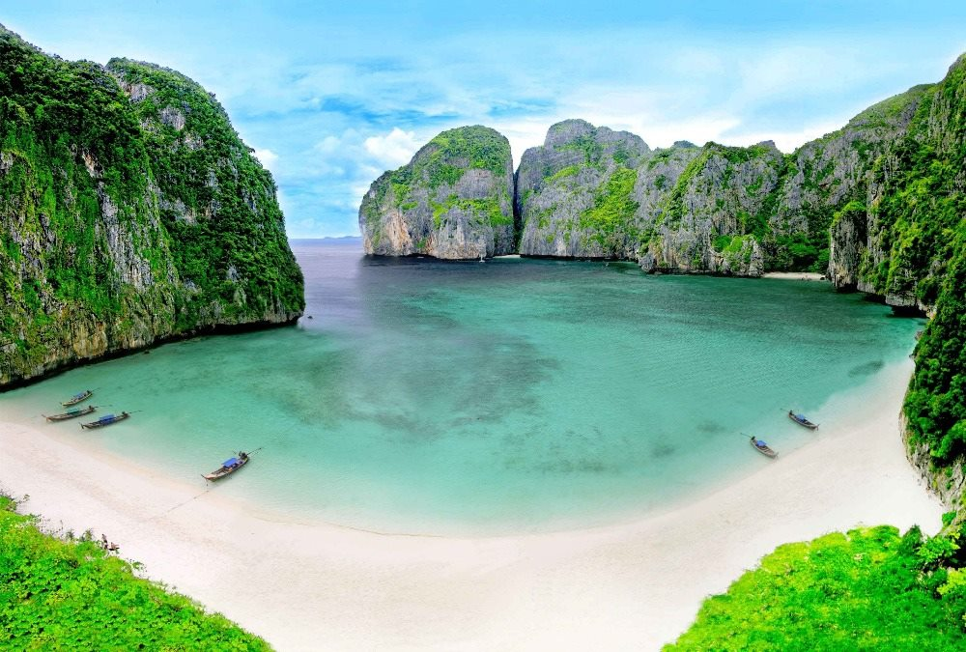
After lunch, spend a relaxing, swimming and snorkeling at Bamboo Island, the island is covered by lush vegetation and surrounded by a strip of white sand and a reef that spreads up to 500 meters (5,382 feet) from the shore. The uninhabited paradise location 3 miles (5 kilometers) off the northern tip of Koh Phi Phi Don, provides its masked and finned visitors with the feeling of swimming in an aquarium.
Time: 15:00 depart from the Ao Nang and drive back to your hotel.

Noted:
The price mentioned for hotels located in city center, if any hotels confirmed at picked up place at from Ao Yon, Cape Panwa, Ko Sire, Leam Hin, Ao Por, Naiyang, Naithorn, Layan, Mai Khao, Kamala, Surin, Bang Tao, and the Airport area, the price will be applied surcharged (to be advised)
Price in USD per person
Included: Air-con Vehicle with English speaking guide. Buffet Thai Lunch, Sharing Speed boat with Soft drink, drinking water, Mask & Snorkel, Life Jacket, Fresh Fruit, Park entrance fee.
Remark:
- All rates can be subject to change if the Thai government increase the gasoline prices
- All rate provided for hotels located in City center, any supplement or conditions apply for hotels and resorts outsides the city center.
Back at the resort, enjoy a sunset swim before dinner under the stars.
Overnight: Phuket | Meals: B
Day 9 – Phuket Free and Easy
This flexible day invites exploration beyond the beaches.

Optional Tour: Full day Phang Nga island by Long Tail Boat
Tour type: Private driver and guide/Privte long tail boat (max 09 pax in one)
Duration: 8 hours (07.00 - 17.00h)
Meals: Lunch
Picked up/dropped off: Phuket
Today, meet our guide and driver then explore the best of Phang Nga by land and water on a full-day tour from Phuket (75 kilometres northeast of Phuket), one of nature’s most unusual and beautiful locations, and the site of the 1974 James Bond film “The Man With The Golden Gun” (starring Roger Moore as ‘007’ and Christopher Lee as the title character). This full-day tour departs from Phuket in an air-conditioned coach to enjoy more amazing scenery including the dramatic limestone mountains of Panak Island and Hong Island, before approaching Koh Tapu which has become known as ‘James Bond Island. Next island-hopping in Phang Nga Bay by longtail boat, stop to swim and snorkel at remote beaches and coves, see James Bond Island, and have lunch (included) at the floating village of Koh Panyi.
Tour end at your hotel in city center.
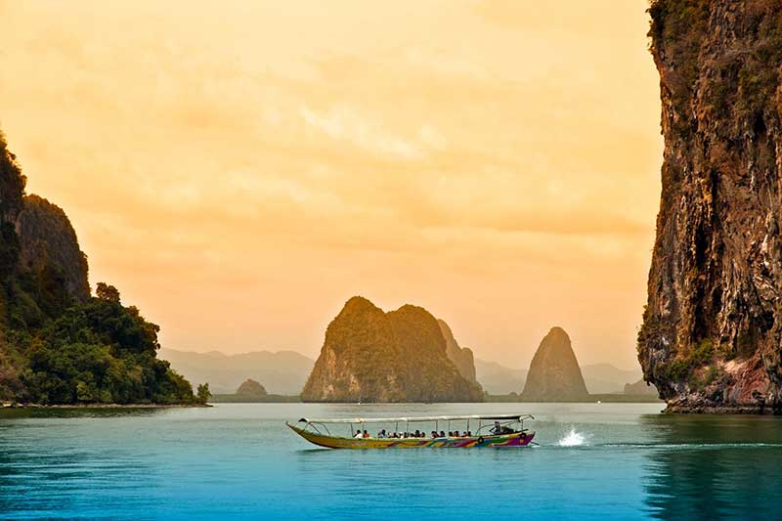
Noted:
The price mentioned for hotels located in city center, if any hotels confirmed at picked up place at from Ao Yon, Cape Panwa, Ko Sire, Leam Hin, Ao Por, Naiyang, Naithorn, Layan, Mai Khao, Kamala, Surin, Bang Tao, and the Airport area, the price will be applied surcharged (to be advised)
Special note: Long Tail Boat can cover from 1 to 09 pax, from 10 pax we will arrange 02 long tail boat.
Price in USD per person

Included: Air-con Vehicle with English speaking guide. Buffet Thai Lunch, Long Tail boat with Soft drink, drinking water, Canoe fee, Mask & Snorkel, Life Jacket, Park entrance fee.
Remark:
- All rate provided for hotels located in City center, any supplement or conditions apply for hotels and resorts outsides the city center.
- Deduction for lunch: -$8/pax (suggestion that must be included lunch).
Or you can cap the afternoon with a wellness session—Thai herbal compress, aromatherapy, or a gentle spa ritual to reset body and mind. The evening is yours for a final seafood feast or night market browsing.
Overnight: Phuket | Meals: B
Day 10 – Phuket Departure → onward flight.
Savor a lazy breakfast with ocean views before your airport transfer. Carry home the sparkle of Bangkok’s temples, the cool mountain air of Chiang Mai, and the sun-washed calm of Phuket—three chapters of Thailand in one balanced journey.
Overnight: — | Meals: B

Inclusions
- Accommodation: 9 nights in handpicked hotels (2BKK, 3CNX, 4HKT), double/twin share.
- Meals: Breakfast daily as per itinerary (B only unless stated).
- Airport transfers: Private A/C on arrival in Bangkok and departure from Phuket.
- Touring transport: Private A/C vehicles for scheduled sightseeing in Bangkok & Chiang Mai.
- Domestic rail: Overnight A/C sleeper Bangkok → Chiang Mai (2nd-class berth; upgrade on request).
- Entrance fees: Included for listed sites on guided days (Grand Palace, Wat Pho, Wat Arun, Doi Suthep, craft villages).
- Guiding: Licensed English-speaking guides on sightseeing days in Bangkok & Chiang Mai; in Phuket (guide only with optional tours).
- Boat/ferry: Public/local ferry on Bangkok temple day as applicable.
- Drinking water: 1–2 bottles per person per sightseeing day (Bangkok/Chiang Mai).
- Taxes & service charges: All prevailing government taxes on included services.
- 24/7 in-country support: English hotline for urgent assistance.

Exclusions
- International airfares & visas: Flights to/from Thailand and Thai visa if required.
- Domestic flight: Chiang Mai → Phuket (economy; standard checked + carry-on allowance per airline).
- Travel insurance: Comprehensive medical, trip interruption, and activity cover.
- Meals not mentioned: All lunches/dinners unless specified; beverages beyond provided water.
- Optional activities: Elephant-friendly experience/cooking class in Chiang Mai; Phang Nga Bay/Phi Phi/island cruises in Phuket; spa/wellness/evening shows not listed.
- Early check-in/late check-out: Not included unless pre-booked.
- Personal expenses: Laundry, minibar, phone calls, room service, souvenirs, incidentals.
- Gratuities: Tips for guides/drivers/crew at traveler’s discretion.
- Peak/holiday surcharges: Supplements during Songkran, Christmas/New Year, Chinese New Year, or hotel “blackout” dates.
- Unspecified transfers: Any transport on free days or services not stated.
- Extra baggage fees: Any baggage beyond airline allowance or policy changes.

